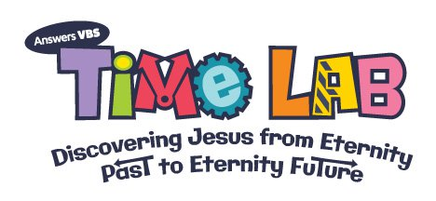
Where: Zion Blue Mountain  United Church of Christ | Time: 5:45 pm – 6:05 pm (Dinner)  6:05 pm – 8:30 pm (VBS)
When: Sunday, July 22 – Thursday, July 26 | Ages: 3 Years – 6th Grade (Fall ‘18)
PRE-REGISTER TODAY! Call 610-488-7361 or complete and return the registration form to Zion Blue Mountain UCC, PO Box 98, Strausstown, PA 19559.

Zion Blue Mountain United Church of Christ
2018 Vacation Bible School Registration Form (Please Print)
Section 1: Parent’s Information
Name: | Address:
Phone #: | Email Address:
Home Church: | Attend Church:

Section 2: Emergency Contact Information
Name #1: | Phone #:
Name #2: | Phone #:

Section 3: VBS Participant Information
Child #1: | Age: | Grade (Fall 2018):
Allergy/Medical or Special Needs Information:

Child #2: | Age: | Grade (Fall 2018):
Allergy/Medical or Special Needs Information:

Child #3: | Age: | Grade (Fall 2018):
Allergy/Medical or Special Needs Information:
*All participants will be photographed for inclusion in a multi-media presentation to be shown at a post-VBS church service.

