Dew Drops
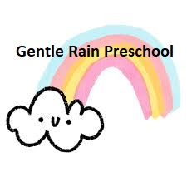
November/December 2023

P.O. Box 98, Strausstown, PA 19559
Contact us at: (610) 488-0509, preschoolgentlerain@gmail.com, or through the Brightwheel App

Our Teachers Who Are Helping Little Minds Grow:

Ms. Carrie (Director)
Ms. Jess
Ms. Kimi
Ms. Sharon
Ms. Becca
Ms. Rachel
Important Reminders and Information:

When calling your student off sick, please give us details of the illness. It is important to know the details especially with all the viruses going around. You may call, email, or message via Brightwheel.

Remember No School On…

November 22nd (Wednesday) to November 27th, 2023 (Monday) for Thanksgiving Break. Classes resume on Tuesday, November 28th, 2023.

December 25th, 2023 (Monday) to January 2nd, 2024 (Tuesday) Christmas Break/Teacher Inservice Days. Classes resume on Wednesday January 3rd, 2024.
Thanksgiving Feast

We are excited to be hosting our first annual Gentle Rain Thanksgiving Feast on Tuesday, November 21st at 11:45am. All students and their immediate families are invited to enjoy spending some time together before the start of our Thanksgiving break. More information has been sent home in folders. Sign-ups for attendance and side dish donations will be available until Friday November 17th. Hope to see you there!

Fall Fundraiser Updates

Thank you to all who participated in our R&K Sub fundraiser. We made a little over $600 to help pay off the new fence and the wooden boat addition. The boat has been a huge hit with the preschoolers.

The gift card fundraiser will run until December 15th. We have extra order forms if needed. Please just ask and one will be sent home with your student.

Salvation Army Angel Tree

Zion Blue Mountain UCC and Gentle Rain Preschool will again be helping the Salvation Army with their Angel Tree. If you would like to sponsor a child for Christmas this year, please take one of the cards hanging outside our PreK classroom. Return the unwrapped gifts by Friday, December 1st.
2023 Christmas Program

We are already hard at work learning songs for our 2023 Gentle Rain Christmas Program! Join us in the church sanctuary on Friday December 22, 2023 at 10am. We will be raising our voices in song to celebrate the birth of Jesus. Join us after the program for some light refreshments kindly provided by the members of Zion Blue Mountain UCC before the start of our Christmas break. Children will be released to their families after the program.
There will not be a full school day that day.
More information on drop off times and procedures for students who do not normally attend Fridays will come home closer to the program date.

Winter Is Coming!

Please remember to bring your child a warm jacket, hat, gloves, and any other winter items daily. We attempt to go outside everyday even through the winter months. If we do have snow this winter, waterproof boots are also recommended to change into for outdoor play. Please also make sure your child is dressed appropriately for that day’s weather.

Please also double check that your child’s spare clothing is also season appropriate.

A New Classroom ‘Friend’

Early November we found a Luna Moth caterpillar on our playground. We brought it inside and created a habitat for it. After a couple of days happily munching on some sumac leaves, we came into school to find it had created a chrysalis! We will be closing watching its progress over the next few weeks in hopes to have it emerge as a beautiful moth like the one pictured here!
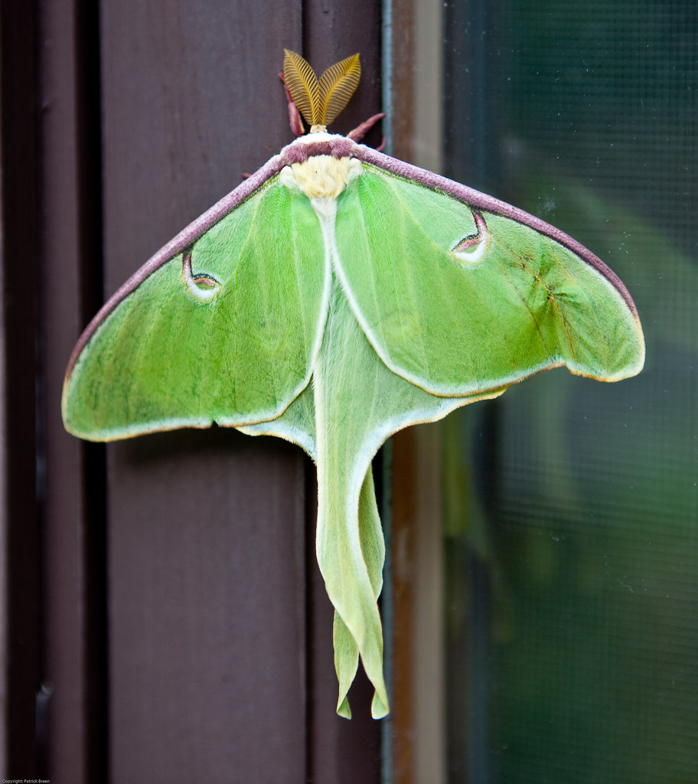

Important Health and Safety Reminder

We have families who have medically fragile members in their home. What might be a minor illness for us or your student could quickly become dangerous for those high-risk family members. Please make sure you are assessing your student’s health each morning before school and if they are not feeling their best, please keep them home. Make sure you are familiar with our handbook policies on Health and Safety as well.

In order to help keep everyone healthy and at school we are also asking everyone to have their student wash their hands before entering the classrooms each morning. The PreK class can use the men’s and women’s restroom in the hallway. We do also have our classroom bathroom that can also be used. Be mindful that there is only one sink in that bathroom though. The ¾ year old class can use their bathrooms just outside their classroom.

Thank you so much for helping to keep everyone safe, healthy, and learning this school year!!
Parent Teacher Conferences

After Thanksgiving Break, we will begin student assessments and preparing for conferences. Conferences are a great way for both parents and teachers to collaborate and ensure each of our students is getting the best preschool experience possible. These will be offered in December. More information on dates, times, and how to sign up will come home in your child’s folder after break.

